ORDER OF WORSHIP Gathering of God’s People

Welcome

*Passing of the Peace

Prelude

Call to Worship
L: In times of busyness and stress when we feel surrounded by challenges on all sides…
P: We gather to learn to strive side by side with one mind for the faith of the gospel.
L: In times of joy and rest when we feel the goodness of God’s provision and abundance deep in our bones…
P: We gather to learn to strive side by side with one mind for the faith of the gospel.
L: In times of conflict and distress when we feel just how hard it is to live in unity together…
P: We gather to learn to strive side by side with one mind for the faith of the gospel.
L: Disciples of Christ, come, let us worship God who empowers us to press on…
P: As we learn to strive side by side with one mind for the faith of the gospel.

Opening Prayer
*Hymn of Praise Immortal Invisible UMH 103

*Affirmation of Faith I believe in God the Father Almighty, maker of heaven and earth; And in Jesus Christ his only Son our Lord: who was conceived by the Holy Spirit, born of the virgin Mary, suffered under Pontius Pilate, was crucified, dead, and buried; the third day he rose from the dead; he ascended into heaven, and sitteth at the right hand of God the Father Almighty; from thence he shall come to judge the quick and the dead. I believe in the Holy Spirit, the holy catholic church, the communion of saints, the forgiveness of sins, the resurrection of the body and the life everlasting. Amen.
*Gloria Patri Glory be to the Father and to the Son, and to the Holy Ghost. As it was in the beginning, is now, and ever shall be. World without end. Amen. Amen.
Pastoral Prayer
The Lord’s Prayer
Dedication of Tithes and Offerings

Offertory

*Doxology
Praise God from whom all blessings flow; praise Him, all creatures here below; praise Him above, ye heavenly host; praise Father, Son, and Holy Ghost. Amen.

Children’s Sermon

Proclamation of the Word

Anthem Guidance Medley Mauldin
Chancel Choir

Epistle Lesson Matthew 20:1-16
This is the Word of God for the People of God. Thanks be to God.

Sermon “Parable of the vineyard owner” Pastor Ryan

Sending Forth

*Hymn of Invitation and Dedication
Make Me A Servant FWS 2176

*Benediction
As you go from this place, may God bless you with wisdom, courage, and perseverance to live your life in a manner worthy of the gospel of Christ as you work, rest, play, and strive side by side with one mind for the faith of the gospel. Amen.

*Congregational Choral Response
Shalom to you now, shalom, my friends. May God’s full mercies bless you, my friends. In all your living and through your loving, Christ be your shalom, Christ be your shalom.

*Postlude
~~~~~~~~~~~~~~~~~~~~
Liturgist: Wade Green

Prayers for…
the people of Ukraine, Israel, and Gaza.
our men and women serving in harm’s way.
neighbors served by our ministries
those fighting and affected by the wildfire in Calhoun County and Highland Industrial Park

our church family… Bonnie House, Wanda Shambley, Verna Riley, Fred Dietrich, Brenda Grimes, Joe Hirsch, Ron Randolph, Neelie Dobbins, Sue Gregory, Bill Gibbs, Joan Coffey, Mari Weidmann Sutterfield, Tina Freeman, Joann Newcomb, Bernie Dickson, Dick Dickson, Dick Newcomb, Ed House (Timberlane), Earl Crumpler

extended family… Bobby Clayborn, Charlie Atkins, Greg Nettles, Jay Williams, Robyn Yarbro, Willie Gibson, Elizabeth Rowlett, Anita Walker, Allen Dawson, James Louviere, Judy Bethea, Paige Carey, Chandlr Mitchell, Jill Canfield, Jerry “Tiny” Pickett (Hospice)

homebound or assisted living …Joyce Mann, Danny Barnes, Sarah Shirey, Ruth Dempsey, Pat Beasley,
Ann Ellen, Fay Kendrick, Pat Stringfellow

South District Prayer Partner…Wiley Chapel Ozan, AR

Camden First United Methodist Church Staff
Pastor………………………..Rev. Ryan Bachuss
Administrator………………..Erin McAllister
Choir Director/Organist……..Cynthia Outlaw
Director of Missions………...Tate Wunnenberg
Director of Preschool………..Jill Daugherty
Asst. Director of Preschool….Kyla Pace

This Week at Church
Sunday, September 20, 2026
9:00am Worship Broadcast on FM 97.1 9:30am Sunday School 10:30am Worship
Monday, September 21, 2026
9:00am Food Pantry
11:00am Strong Women
2:30pm Great Hall Doors Open
4:45pm Sue’s Table
6:00pm Bible Study
Tuesday, September 22, 2026
8:30am Preschool
9:00am Food Pantry
Wednesday, September 23, 2026
8:30am Preschool
11:00am Strong Women
6:30pm Handbells
7:00pm Choir Practice
Thursday, September 24, 2026
8:30am Preschool
Friday, September 25, 2026 9:00am Food Pantry 11:00am Strong Women

The full worship service is broadcast on FM 97.1 on Sunday mornings at 9:00am. The Worship Service is available on our YouTube channel -

First United Methodist Church Camden, AR
121 Harrison Street Camden, AR 71701 870-836-6871 Email - fumccamden@sbcglobal.net
Website – www.camdenfumc.com
Facebook: First United Methodist Church Camden AR
Instagram: fumccamden

First United Methodist Church
Camden, Arkansas

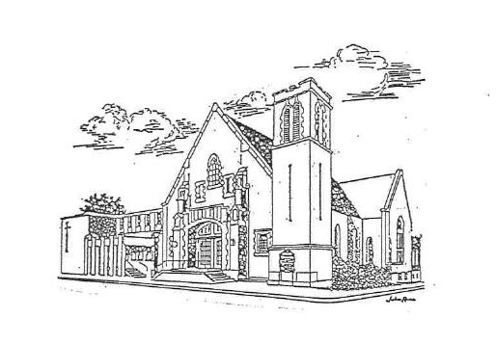

Seventeenth Sunday after Pentecost

September 20, 2026

Following Jesus
Loving People

